**Please make a copy of this document (do not ask for edit permissions)**Replace the highlighted part of this proposal with your team’s answers.   
Please see the limits of each answer below. You may exceed one page if necessary.

**Company : Kitabisa**

**Problem Code : [C22-OA] Kitabisa - On-demand Ambulance**

**Team Member:**

* **(ML) M2014J1403 - Ida Bagus Dwiweka Naratama**
* **(ML) M2320J2803- Theophil Henry Soegianto**
* **(ML) M7007F0752 - Baihaqi Muhammad**
* **(MD) A2014J1402 - Dewa Ngakan Made Bagus Krishna K.**
* **(MD) A2320J282 - Ricky Andrean Fernanda Gunawan**
* **(MD) A2014J1406 - A.A. Gde Agung Smaraputra**
* **(CC) C2320F2800 - Made Yoga Brahmantara**
* **(CC) C2320F2809 - Jasti Ohanna**
* **(CC) C7320f2798 - Christopher Tri Anugrah**

**Why is this problem/project interesting for your team?**

It’s important to facilitate help to a critical situation immediately for everyone, as ambulances are scarce resources for mid-low society.

Dewa :

Because the project is very useful to optimize ambulance performance and save many people’s lives.

Toto :

In Indonesia, ambulance hasn’t been used 100% functionally. With this project it can maximize ambulance for emergency situation

Nara :

Ambulance is an important facility that anyone who needs it must get it immediately

Ricky :

Because we want to digitize the ambulance mechanism so that it can be implemented better than conventional systems

Yoga:

because this project can make it easier for anyone to get an ambulance in an emergency. and get the estimated time and distance from the ambulance to the scene

Jasti:

We believe by developing and implementing this project it can give huge impact to our society, especially giving more opportunities to save more life. Ambulance is still known as scarce resources especially for the mid-low society class.

**What’s your group’s initial idea to work on this project?**

[your answer, (Paragraph, up to 100 words)]

Kesimpulan :

Users can register in the app, with sufficient information and emergency number. Witnesses or users themselves, can call an ambulance with a press of a button. Users can see the current location of the ambulance, distance, and its estimated time of arrival. The user may interact with the app to see more information on what to do about the current situation. If ambulances are not available, other resources will be available. Witnesses may identify the victim using KTP optical recognition. The data will appear according to the user’s consent.

Dewa:

Blablabla emergency call feature

Nara :

Apps that have emergency call feature for ambulance and integrated with hospital nearby. Not just the ambulance, public nearby can also help and participate to help each other who need it in emergency situation.

Toto :

Apps to help people in emergency situation, with just a few click of button it will call an ambulance to go where you are, and if the ambulance isn’t ready it can broadcast to many user that use the app to help you. Plus, you can immediately get to call our customer service to help you with first help or asking you some information, so our CS can contact the hospital for better help and preparation.

**[ Theo ]**

An application that lets witnesses choose the problem that occurs, and click a button to call an ambulance whilst broadcasting the information to nearby logged in volunteers. Nearby volunteers may help by giving a suggestion in the open thread discussion. If an ambulance is available, it will come to pick the patient. But If it’s not, a verified volunteer may help to drive the victim to the hospital. The app will also provide some additional first-aid information, while the victim and witnesses wait.

Jasti:

**Does your team have unique solutions to be proposed?**

[your answer, (Paragraph, up to 100 words)]

Kesimpulan :

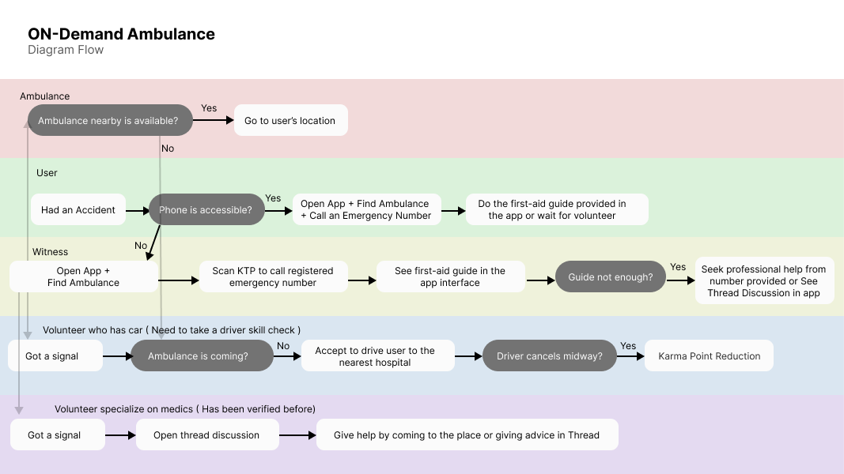

If ambulance isn’t available, the app broadcasts messages to nearby users, to see whether there’s a volunteer to drive the victim to the hospital. If the volunteer succeeds, they receive points. The victim can be identified by scanning KTP, then emergency number will be called, if the user consents. While waiting for the ambulance/volunteer’s car the user may see a first-aid guide on the screen, seek help in Thread Discussion with other volunteers, or call professional from the provided number in the app. After it, we provide fundraising and blood donation for the patient that is integrated into another app.

Dewa :

If the ambulance is not available, user can ask for help as a broadcast to nearby users and they can send a confirmation if they can help directly or not. If so, they can escort or give a first aid to the victim, and the app will also update the case details such as victim condition, hospital destination, or the follow-up actions like blood donors request or fundraising (connect to Kitabisa app). If the user can’t help directly, they still can help by sending message in a public chat that automatically generated when the broadcast sent.

Nara :

Yes of course…

In emergency situations, everything can be happened. But, can ambulance provide it to all victim? Our app can broadcast it to other user nearby to help if the ambulance in busy. Our app will inform it soon to emergency contact on user phone so user’s friend can help it soon. While the user in emergency thing, there’re some information too on app to give it first aid depends on situation the user situation. The app can also detect user nation id to make hospital or cop report easier.

Toto :

Instead of just calling 1 ambulance, it will ask 3 nearby ambulance if they are ready. If none of them ready it will broadcast nearby user app to help you too. Our app can give guide too for first help.

**[ Theo ]**



Punyaku kurang KTP for emergency contact, dan Fundraising

**Based on your knowledge, what tools/IDE/Library will your team use to solve the problem?**

[your answer, (List of tools, IDE, Library, platform, API)]

Dewa :

Android Studio, Google Maps API

Ricky :

Google OAuth, Jetpack Library

Toto :

Google Maps API Directions Service

Nara :

Visual Studio Code, Tensorflow, opencv2, … (aku lupa)

**Based on your knowledge and explorations, what will your team need support for?**

[your answer, (List of items, mentors, data, supporting resources)]

Dewa :

Google Maps API credential (so we can use Geofencing for free), API to connect our app to Kitabisa (for fundraising things)

Nara :

OCR (optical character recognition) to validate user nation id so hospital or cop can make the report faster. Computer Vision to detect what happened in a nearby situation.

**Any other notes/remarks we should consider on your team’s application**

[your answer, (Optional, Paragraph, up to 100 words)]

Nara :

-

Theo :

We provide help, not only right as the problem occurs, but also after it has happened, by integrating our app with blood donation and fundraising. We unite the people, by providing a service to help each other voluntarily. We believe we can achieve great things, when we unite as a community. We respect user’s confidentiality by having a consent system for emergency phone calls, and verify user data will be safe. We want to give the help to the community immediately as it is an urgent service. We will have a sophisticated system that runs and integrates well.